The smell of rain
At the end of this story, it gives you two options. I think you will figure out what option I chose.

A cold March wind danced around the dead of night in Dallas as the doctor walked into the small hospital room of Diana Blessing. She was still groggy from surgery.

Her husband, David, held her hand as they braced themselves for the latest news.
That afternoon of March 10, 1991, complications had forced Diana, only 24-weeks pregnant, to undergo an emergency Cesarean to deliver couple's new daughter, Dana Lu Blessing.
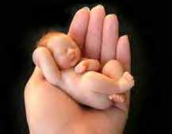
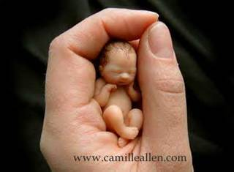
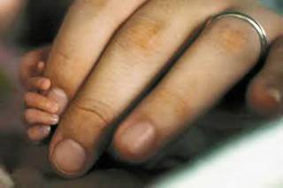
At 12 inches long and weighing only one pound nine ounces, they already knew she was perilously premature.
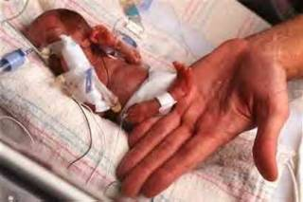
Still, the doctor's soft words dropped like bombs.
"I don't think she's going to make it," he said, as kindly as he could.
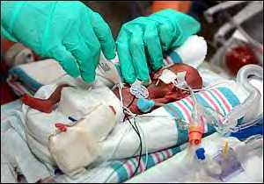
"There's only a 10-percent chance she will live through the night, and even then, if by some slim chance she does make it, her future could be a very cruel one"
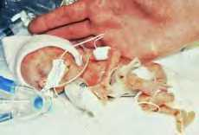
Numb with disbelief, David and Diana listened as the doctor described the devastating problems Dana would likely face if she survived.
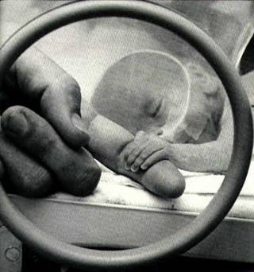
She would never walk, she would never talk, she would probably be blind, and she would certainly be prone to other catastrophic conditions from cerebral palsy to complete mental retardation, and on and on.
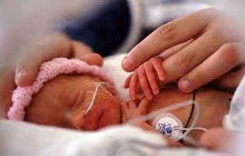
"No! No!" was all Diana could say.
She and David, with their 5-year-old son Dustin, had long dreamed of the day they would have a daughter to become a family of four.
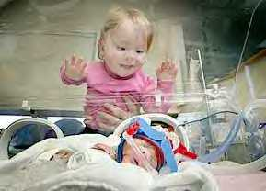
Now, within a matter of hours, that dream was slipping away
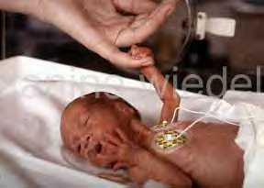
But as those first days passed, a new agony set in for David and Diana. Because Dana's underdeveloped nervous system was essentially 'raw', the lightest kiss or caress only intensified her discomfort, so they couldn't even cradle their tiny baby girl against their chests to offer the strength of their love.
All they could do, as Dana struggled alone beneath the ultraviolet light in the tangle of tubes and wires, was to pray that God would stay close to their precious little girl.
There was never a moment when Dana suddenly grew stronger.
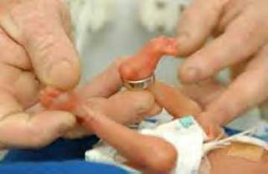
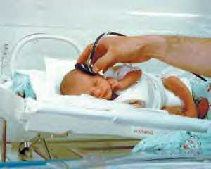
But as the weeks went by, she did slowly gain an ounce of weight here and an ounce of strength there.
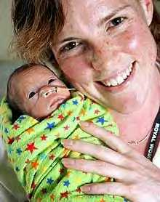
At last, when Dana turned two months old. her parents were able to hold her in their arms for the very first time.

And two months later, though doctors continued to gently but grimly warn that her chances of surviving, much less living any kind of normal life, were next to zero, Dana went home from the hospital, just as her mother had predicted.
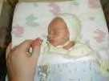
Five years later, when Dana was a petite but feisty young girl with glittering gray eyes and an unquenchable zest for life.


She showed no signs whatsoever of any mental or physical impairment. Simply, she was everything a little girl can be and more. But that happy ending is far from the end of her story.
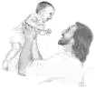
One blistering afternoon in the summer of 1996 near her home in Irving, Texas, Dana was sitting in her mother's lap in the bleachers of a local ball park where her brother Dustin's baseball team was practicing.
As always, Dana was chattering nonstop with her mother and several other adults sitting nearby when she suddenly fell silent. Hugging her arms across her chest, little Dana asked, "Do you smell that?"
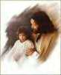
Smelling the air and detecting the approach of a thunderstorm, Diana replied, "Yes, it smells like r ain."
Dana closed her eyes and again asked, "Do you smell that?"

Once again, her mother replied, "Yes, I think we're about to get wet. It smells like rain."
Still caught in the moment, Dana shook her head, patted her thin shoulders with her small hands and loudly announced,
"No, it smells like Him.
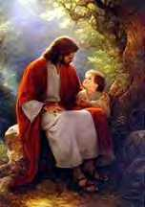
It smells like God when you lay your head on His chest."
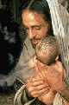
Tears blurred Diana's eyes as Dana happily hopped down to play with the other children.
Before the rains came, her daughter's words confirmed what Diana and all the members of the extended Blessing family had known, at least in their hearts, all along.
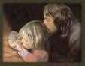
During those long days and nights of her first two months of her life, when her nerves were too sensitive for them to touch her, God was holding Dana on His chest and it is His loving scent that she remembers so well.
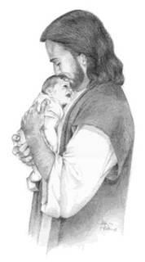
You now have 1 of 2 choices. You can either pass this on and let other people catch the chills like you did or you can delete this and act like it didn't touch your heart like it did mine.
IT'S YOUR CALL!
"I can do all things in Him who strengthens me."
This morning when the Lord opened a window to Heaven, He saw me, and He asked: "My child, what is your greatest wish for today?" I responded:
"Lord please, take care of the person who is reading this message, their family and their special friends. They deserve it and I love them very much" The love of God is like the ocean, you can see its beginning, but not its end.
________________________
This message works on the day you receive it. Let us see if it is true. _____________
ANGELS EXIST but some times, since they don't all have wings, we call them FRIENDS
_________________________
Pass this on to your true friends. Something good will happen to you at 11:00 in the morning; something that you have been waiting to hear.
This is not a joke; someone will call you by phone or will speak to you about something that you were waiting to hear.
Do not break this prayer; send it to a minimum of 5 people

