Revolution or evolution? Considering the impact of 'emerging church' conversations on the mission and ecclesiology of established churches.
Dr. Dion A Forster

[Draft version – please contact the author for a completed version after the lecture, or for a copy of the Powerpoint slides referred to in the text below]

Outcomes.
By the end of this lecture you should be able to:
[slide 2]
- Articulate a clear understanding of the relevance of the Gospel of Christ for contemporary society.
- Articulate some understanding of how and why society is moving away from traditional models of the Church.
- Explain what some of the implications of this shift is for the Church and the Christian faith.
- Offer some insight into alternative, and fresh, expressions of the Christian faith community.
- Make a clear case for Churches, and individual Christians, to deliberately and strategically incarnate themselves, and the Gospel of Christ, in their context for the sake of the Kingdom of God and the world.

Prolegomenon.

It is a great honour and blessing to be with you this evening. I have looked forward to this event for well over a year now! I first found out about this lecture series from Geoff Cornell, and I suspect my invitation to be here this evening came as a result of the kind grace of Leao Neto, whom I met at the Oxford Institute in 2007. Thank you to Sue and Daniel for their hospitality and for all of the arrangements that they have made on my behalf. As I looked over the program for 2009, and considered some of the persons who have had the privilege to participate the Hugh Price Hughes lectures in the past, I feel a real sense of gratitude and am truly humbled – my life has been filled with the kind blessings brought about by the generosity of others. Thank you, of course, to those who are in attendance here tonight, and for those who will read, and listen to, this lecture at a later stage.

Now, having dispensed with the word of thanks let me offer the customary prolegomenon!

Theology is a discipline that is crafted in the lives of people, it is sparked in our hearts and minds, is expressed through our words and symbols, and of course it is sharpened and shared in community. As such, when I have read or heard a particular ‘theology’ being presented, I have always found it helpful to know who is speaking to me about their perspective of God! The greatest truths that I have come to know about God have come through relationships, so let me attempt to establish something of a relationship with you by sharing my particular perspective on the Christian faith.

I am an African, born in Zimbabwe, when it was still known as Rhodesia. I grew up in South Africa and came to faith in my late teens. My entry into Christianity was marked by two diverse influences. On the one hand was a very real experience of the regenerative work of God’s Spirit – something of an evangelical conversion under the guidance of a Methodist minister in training in the suburbs of Johannesburg. I have been an evangelical of a sort ever since, although I will confess that I am not an evangelical in the contemporary usage of the word. I shall say more about this at a later point in my lecture.

The second significant influence, that I allude to above, came from the reality of South Africa’s political turmoil in the late 1980’s and early 1990’s. These were the years in which my discipleship took shape and my calling to full time ministry was answered. I was fortunate to be taken under the wing of Bishop Paul Verryn, a white Methodist minister who lived and worked in South Africa’s largest black township – SOWETO. Here I learned that the passion of the Gospel needed to be directed towards the destabilisation of the oppressive APARTHEID system, and that the Christian faith was fundamentally political in nature since it seeks to address both individuals and structures in society. Since those days I have remained an activist! I have sought to work for the transformation of society, the liberation of the oppressed and the establishment of just, fair and inclusive social structures. Sadly, I came to discover that this work, some would call it a ministry, is as sorely needed inside of the Church as it is in secular society. Whenever I have an occasion to do so I still speak about, write about, and work for a more just South Africa. I still agitate for the inclusion of all persons in supportive communities. In the last number of years this has meant that much of my time and energy is spent working against unjust political, economic and social systems – I manage two large charitable trusts. It has also meant that I have taken a fairly unpopular stance on the issue of the Church’s exclusion of persons who are different from the ‘norm’ (i.e., persons with a same sex orientation, persons who choose to exercise their gifting and spiritually in less conformist manners, persons who occupy various exclusive corners of conviction (whether these be liberal or conservative), protecting those who do not have access to power and decision-making structures in the Church).

My faith has always felt natural! However, my theologically conservative and evangelical friends found my liberal views disconcerting, and my liberal friends found my evangelical zeal concerning. It was, however, with great joy that I later discovered that these two elements are not at odds with each other! In fact, I came to discover that there were (and are) many other Christians who hold themselves to be both post liberal and post evangelical, holding a radical commitment to the whole Gospel and a radical commitment to social justice in creative tension. In fact I came to discover that the founder of the Church of which I am a minister, John Wesley, had just such a pragmatic and passionate theology, most clearly expressed in his understanding of Christian perfection! So, I have rejoiced to live into this balance between personal holiness and social holiness at every possible opportunity. I have come to own the fact that I was an ‘emergent’ Christian long before it was a category in contemporary theological discourse.

So, I hope this offers some insight and background against which to consider what I am about to say.

- Introduction.

[Slide 3] The content of my lecture can be summed up in the answer that one may give in response to two questions:

- Is there still a place for the Gospel of Christ in contemporary society?
- Do contemporary Christians, and the contemporary Church, have the courage and critical insight to make the necessary changes to effectively engage the world with the transformative truth of the Gospel of Christ?

It is my guess that most of us who are present here this evening will answer both questions in the affirmative. Yes, the Gospel of Christ does still have a place in (and a voice) in contemporary society. And, yes, Christians, and the contemporary Church do have the courage and necessary critical insight to change themselves in order to effectively engage the world with the transformative truth of the Gospel.

Have you ever considered, however, that this answer may be based more upon our love for the Church and our ‘Churched’ perspective than on unbiased and informed consideration? The reality is that decline in Church membership and attendance is an indicator that the Gospel of Christ is finding less and less place in contemporary society. Moreover, the models of Church that we are using to present to Gospel to society are no longer effective or acceptable to those whom we are attempting to address. We shall consider some of the statistics of Church decline in a few moments.

However, I feel that it is safe to say that if we are truly committed to bringing the Gospel of Christ to bear on contemporary society we shall need apply some radical changes to the models of the Church that have dominated Western Christendom for some centuries.

Elizabeth Carnelly, an Anglican, shares the following humorous insight about change in the contemporary Church. She asks:

How many Anglicans does it take to change a light-bulb? Two – one to write a liturgy for it and one to do it.
How many Methodists does it take to change a light-bulb? One – but why does it need to change?

In this lecture I shall attempt to offer some insights that can help us to answer the question whether the Church needs a complete revolution, or whether a gradual evolution of Church models will suffice in bringing the Gospel to bear on contemporary society.

- Is the Church dying or simply changing?

In preparing for this lecture I was not surprised to find a great deal of debate on the most recent, and comprehensive, report on Church attendance in the UK. Ruth Gledhill pointed out the a ‘Divine decline’ in Church attendance, that she predicts will lead to a radical decline in functioning Churches in the UK, with the following alarming projected statistics [Slide 4]:

Churches 2005

48,328 - including 18,503 Anglican, 4,585 Catholic and 6,062 Methodist

Churches 2050 (projection)

27,473 - including 4,014 Anglican, 3,359 Catholic and 2,037 Methodist.

This dismal projection is based on the trend of declining Sunday attendance at Church services in the UK since 1968 as the following graph shows [Slide 5].

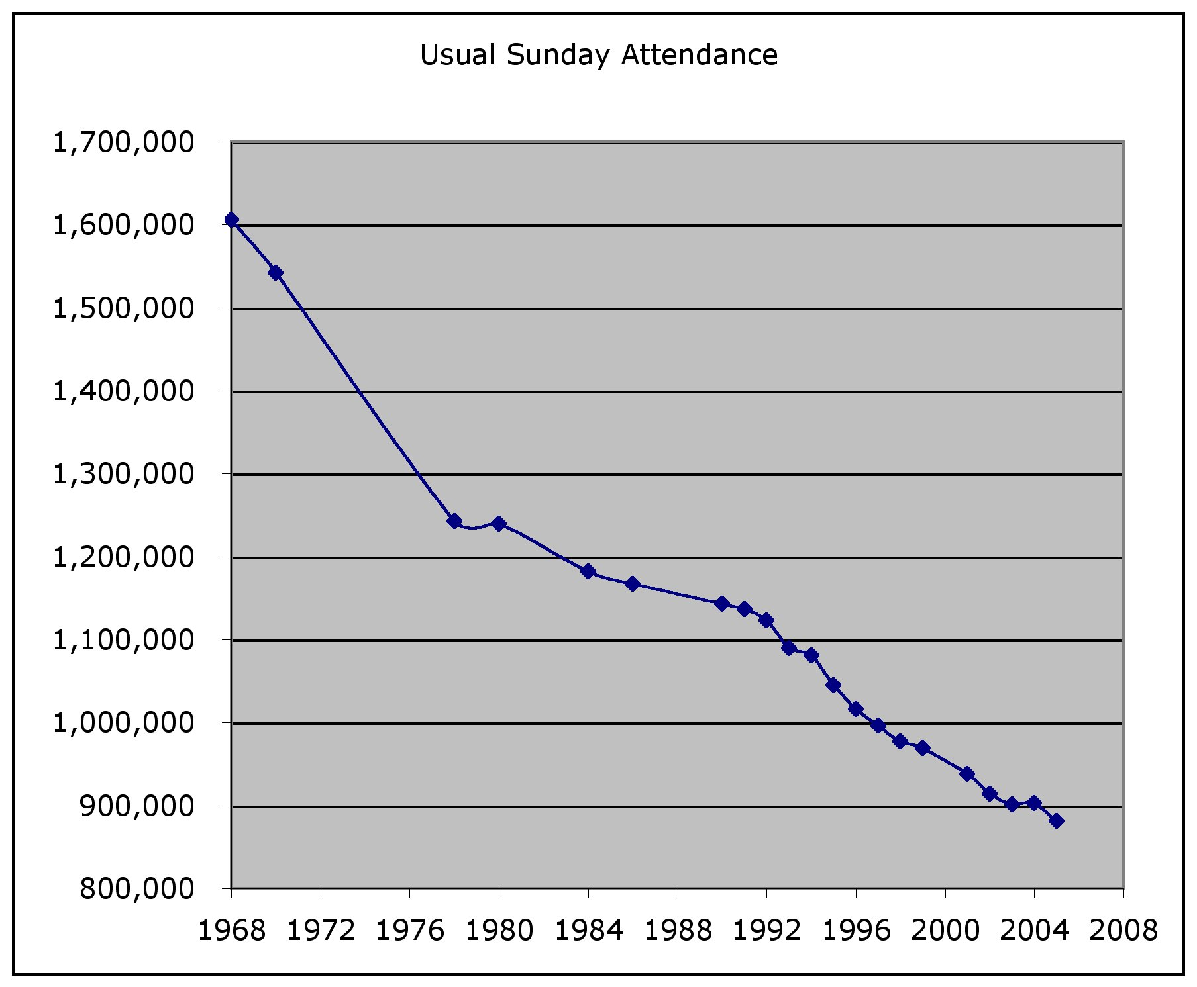

The controversy over this research was not sparked by the statistics themselves; rather it was Gledhill’s comparative statement about Christianity’s decline in relation to the growth of Islam that caught the public’s attention. Gledhill writes,

“Church attendance in Britain is declining so fast that the number of regular churchgoers will be fewer than those attending mosques within a generation…. The forecast to 2050 shows churchgoing in Britain declining to 899,000 while the active Hindu population, now at nearly 400,000, will have more than doubled to 855,000. By 2050 there will be 2,660,000 active Muslims in Britain - nearly three times the number of Sunday churchgoers”.

This is a controversial statement on many levels, and the Church of England’s Lynda Barley correctly points out that:

“There are more than 1.7 million people worshipping in a Church of England church or cathedral each month, a figure that is 30 per cent higher than the electoral roll figures and has remained stable since 2000,” she declared.

"The research does not compare like with like”, Ms Barley says. “The number of practising Muslims, for instance, is based on the number of people who said they were active in the 2001 census. If the same process was applied to Christians it would give a figure of 20 million active churchgoers” .

One could add to the above that there are some significant cultural factors that affect the reporting of faith – Gibbs and Coffey note the “Halo effect” among certain cultural and religious groups with a strong sense of hegemony. By this it is suggested that persons who would formerly have reported themselves as Christian, or occasional in Church attendance, are less likely to do so in a secular society. However, persons of faith groups in which there is strong community pressure to belong to a faith community would be less likely to openly express dissent of the communal view. I do not wish to go into the debate about Gledhill’s statements concerning the comparative number of Christians and Muslims in the United Kingdom. What is clear, however, is that regular Church attendance is in a radical decline. As an aside, highly ‘Churched’ societies such as those in South African and the United States are still to face some of these challenges in years to come. Active Church attendance in England and Wales in 1851 was at about the same level as it currently is in South Africa and the United States (39%). We are seeing the signs and have a great deal to learn from what you have already done in the UK, and are currently doing, to bring the Gospel of Christ to bear on your context.

The cardinal question in this debate is, however, does a decline in Sunday attendance mean the death of the Church AND the end of the Christian faith? Or are these two things not necessarily related to one another, i.e., is it possible that the Church will die out and the Christian faith will continue without it? I shall return to these questions later. For now I simply leave it for your consideration as I move on to give a very brief and cursory overview of the reasons for a decline in Church attendance and membership.

[Slide 6] Martin Wellings, a Methodist historian, gives a very succinct, yet detailed, synopsis of the two primary factors that have lead to decline in Methodism in the UK in recent history. He lists a spiritual understanding (when ‘the heart grows cold’ and believers fall away from their first love) and a cultural understanding (mainly linked to the sociological impact of secularization on faith). It makes for fascinating reading and certainly supports my few scant thoughts below. I would commend it to you. [Stay slide 6] However, in my mind there are two very pragmatic reasons for Church decline. First, there is Church decline as a result of a lack of new members joining Christian Churches. Second, there is Church decline as a result of people leaving Churches and the Christian faith. Let’s consider the first of these broad factors.

I think it is fair to say that in most countries across the world the mainline Church is simply dying out! It sounds morbid, but it is true. The reality, particularly for mainline Christian denominations, is that the average age of members and regular Church attendees is steadily on the rise. This is particularly evident when one considers recent research on membership and Church attendance in the United Kingdom.

[Slide 7] The following graph clearly shows that whilst the average age of adults in the UK is 35-44 years (19 percent of all adults), the average age of Church members is around 65-74 years of age (accounting for 18 percent of Church attendance).

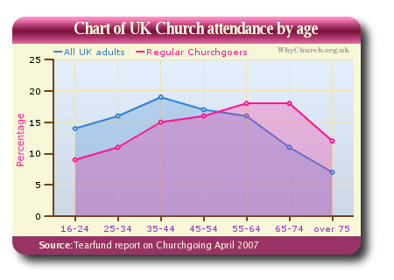
[Slide 8] The following chart shows overall Church attendance (including those under the age of 15).

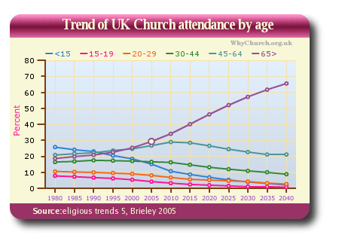
Again, these are projected figures (toward the year 2040) based on current demographic trends in the Church.

One could ask the question why there are fewer and fewer persons joining the Church, and particularly why fewer and fewer young people are joining and staying in Church? This is a hugely complex question to which many very bright persons and groups are applying their best attention. However, the simplest, and most direct, answer to this question must surely be that the Church no longer fulfils a necessary role in the lives of most persons in society! That may be somewhat shocking to hear, particularly for those of us who invest our lives in Church ministry. But, when it comes down to the most basic motivators for human behaviour and choice we will always be able to tell what people need, and where they are having their needs met. The popular saying ‘people vote with their feet’ is quite a good indicator of this reality. I suggest that the Church is simply loosing touch with society and the needs of the context within which it exists. Since the parish Church no longer provides a necessary social service (registering births, marriages and deaths as in the 17th – 19th centuries), it will have to find some other necessary function to perform in order to find a space in the busy lives of people. If it does not add value people tend to move on to other communities and commodities to get what they need.

Two years ago I was asked to contribute a scholarly article for the journal ‘The Epworth Review’ that would be included in a special edition on the Church’s response to global warming and the environment. If I had written the article in accordance with the brief given by the editor, (i.e., what is the Methodist Church of Southern Africa’s response to the crisis of global warming and the environment?) my article would have been less than two paragraphs long! Sadly, our Church has no clear and directed response to this issue. You may say “so what?” Well, the reality is that this is a clear indicator of the fact that we, the largest Christian denomination in Southern Africa, are no longer aligned to the most significant issues facing our world! The Church is occupied with its own internal struggles and issues while the world has an entirely different set of priorities and needs. I would venture that this sad reality is pretty much the same in mainline Christian churches across the globe.

[Slide 9] Danish economist, Bjorn Lomborg, led a widely accepted study known as the Copenhagen Consensus. It brought together experts from various fields such as economics, science, and sociology, to identify and consider what the leading threats are in the world i.e., what are the greatest dangers, and the causes of suffering, in the world? They prioritised these concerns based on which issues could be most effectively addressed based on what could be realistically changed if sufficient funds could be raised. Their list of the top 10 global problems was:

- Hunger and malnutrition
- Climate change
- Conflicts
- Financial instability
- Water and sanitation
- Subsidies and trade barriers
- Population / migration
- Communicable diseases
- Education
- Governance and corruption

Next, we have the 8 top issues the 191 members of the United Nations have pledged to address as ‘Millennium Development Goals’ by 2015. They list the world’s most pressing problems as:

- Eradicating extreme poverty and hunger
- Achieving universal primary education
- Promoting gender equality and empower women
- Reducing child mortality
- Improving maternal health
- Combating HIV / AIDS, malaria, and other diseases
- Ensuring environmental sustainability
- Developing global partnership for development

Let me conclude this point with an illustration of the problem at hand. Brian Mclaren tells of an incident when he was asked to facilitate a youth strategy meeting for a Church group some years ago. The young people of a particular church had asked him to assist them crafting their leadership strategy for the year ahead. Mclaren challenged the young people to write down a list of the most pressing and challenging issues they thought they would face in their congregation in the year to come. They listed things such as the challenge of bringing contemporary worship into their main services, getting enough space for a youth ‘coffee bar’, changing the perceptions of adult members about the manner of dress of young people in Church, a few ‘heavier’ issues like their pastor’s approach to interpreting the Bible and other such concerns. Then he asked them to list the most pressing issues that they believed we are facing on the planet. On this list they had things such as global warming, poverty, war, HIV / AIDS, education and a number of other pressing issues. Mclaren notes that he asked himself a very important question that evening – he wondered, which Church would he like his children to belong to? The one with the concerns of the youth leaders, or the one with the concerns of the world?

I think that many people are asking just such questions about the contemporary Church! My friend, Roger Saner, commented that, “most of the people I know would have to culturally commute from who they are to who the traditional Church is”.

[Slide 10] Barna sadly points out that,

The major changes in spiritual practice over the past half century have been largely window dressing. Pick a trend – mega churches, seeker churches, satellite campuses, vacation Bible school, children’s church, affinity group ministries (e.g., ministries for singles, women, men young marrieds) contemporary worship music, big screen projection systems, EFT giving, cell groups, downloadable sermons, sermon outlines in bulletins, Alpha groups. Al of the above have simply been attempts to rely on marketing strategies to perform the same activities in different ways or places, or with particular segments of the aggregate population.

I have personally experienced some of the struggle of this disconnection between my needs, and the spiritual needs of my family, and the capacity and willingness of my local Church to engage us at that level. I have found that a large proportion of the Church’s teaching and programs centre around its own needs (giving, joining groups, attending to other members in the congregation, maintaining the buildings and institutional structures of the local Church and the national denomination). Yet, I seldom find the Church seeking out creative and effective ways to attend to my most significant needs. I have frequently challenged friends and colleagues in the ministry with the simple truth that the pastoral visit of our day is no longer primarily in the home – rather it is in the workplace. It is an opportunity to meet the member where he or she spends most of their active time, faces most of their challenges and struggles. Out of this lived reality comes a great deal of insight for renewed engagement with the Gospel of Christ. In order to test this feeling I would urge the clergy who are present, and the laity who engage with their clergy, to ask what proportion of time the Church, the members, and the clergy spend discovering and engaging with the needs of their society as opposed to supporting and developing the structures of the local congregation or denomination?

I am clear about the fact that God has a supreme and perfect will both for the Church gathered and for the Church scattered across the city! The one should never be highlighted at the exclusion of the other. Moreover, I am becoming increasingly aware that there is a radical need for ministry methods that take the notion of incarnation seriously. Contextual immersion brings such significant and necessary insights into the needs of the community that one is serving (both as lay ministers and as ordained clergy).

Up to this point I have discussed some of the internal struggles that we have within the Church that prevent us from being effective agents of the Gospel in our context. There is, of course, another huge factor that we need to face, and that is the general perceptions of the Church and the Christian faith in contemporary society and the media. Here are a few perspectives that I found through a fairly cursory search of the internet:

- "Whenever I meet a Buddhist leader, I meet a holy man. Whenever I meet a Christian leader, I meet a manager." ~ Os Guiness, quoting a Japanese businessman.
- Archbishop Rowan Williams commenting on the common bias against the Church and the Christian faith in the media said, "the media know what the story is before you do... and their story about the church is 2 things, conflict and decline.... if those are the grids through which everything is read, it's very hard to break through it. We try."
- “I don’t mind Jesus, but I don’t trust his wife [bride]…” (comment by a sceptical friend).
- It is for this very reason that Peter Brierley has predicted that “60% of all Churches in America will die out by 2050”

[Slide 12] And of course we haven’t helped matters! A friend of mine recently pointed out that Jesus needs new PR (public relations)! I agree with him, and sadly I have to admit that I am part of the problem!

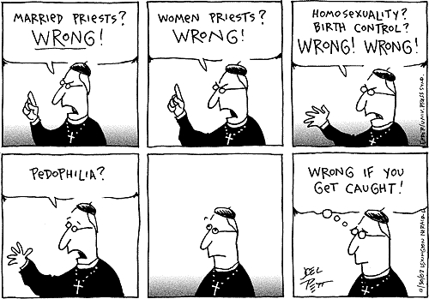

Perceptions are powerful and I’m sure that most of us have come to recognise that it takes a lot of work to build up positive perceptions and very little to break them down.

In the last few months I have had a fair amount of dealings with the Argentinean evangelist, Ed Silvoso. He is a remarkable man who seems to have discovered something of this balance between discerning and discovering the felt needs of a community, and bringing the Gospel of Christ to bear on this reality. I recently heard Ed say something that is so true that it is shocking:

Preaching the truth without love is like giving someone a good kiss when you have bad breath. No matter how good your kiss is, all the recipient will remember is your bad breath!

I do believe that we have a great deal to do in order to restructure our Churches to effectively serve our members, and we have an equal responsibility to find ways of effectively discovering and addressing the needs of the communities in which we live.

[Slide 14] So, to return to the question I asked at the start of this section – is the Church dying or simply changing? The most honest answer I can give is that it is probably a bit of both. In order to answer this question I shall have to speak about the Church in my own context and trust that you will be able to answer the question for the Church in the UK for yourselves.

The reality is that the mainline Church in South Africa is in radical decline – it is dying [Slide 15]. This is a reality in South Africa where Christianity is still in a growth phase. The following graph shows the decline in mainline Church membership in South Africa. Methodists can take note of the fact that we are still the largest mainline denomination in Southern Africa, yet we are facing a radical decline.

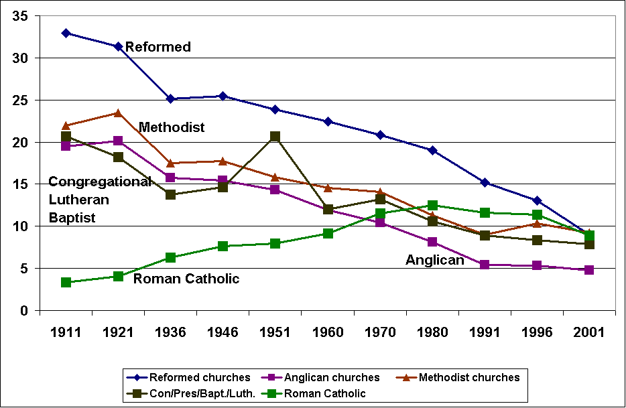

[Slide 16] Compare this to this graph that shows the growth in adherence to the Christian faith as recorded in our last national census.

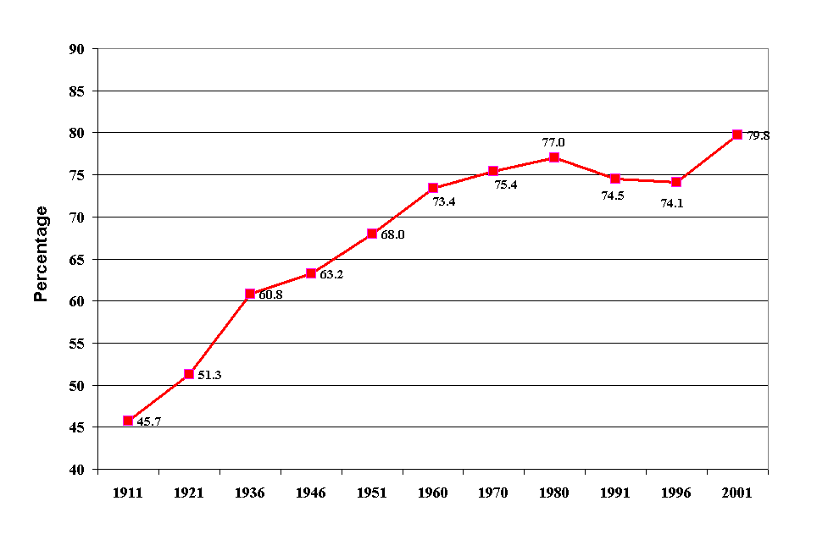
So, 79.8% of the population indicate some form of adherence to the Christian faith, yet Churches are in steep decline. This must mean that people are finding expression for their Christian faith outside of the traditional Church.

[Slide 17] The following graph gives some insight into the variance between growth in the Christian faith and decay in the mainline Churches. First a graph that shows in which sectors of the population Christianity is growing the fastest.
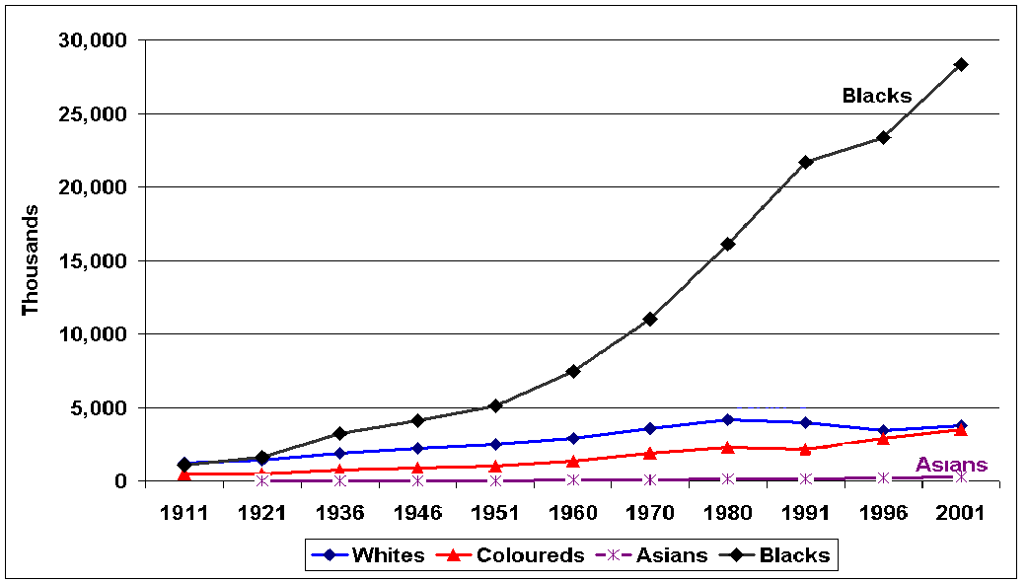

[Slide 18] Next a graph that shows ‘Christian marketshare’ in Southern Africa.

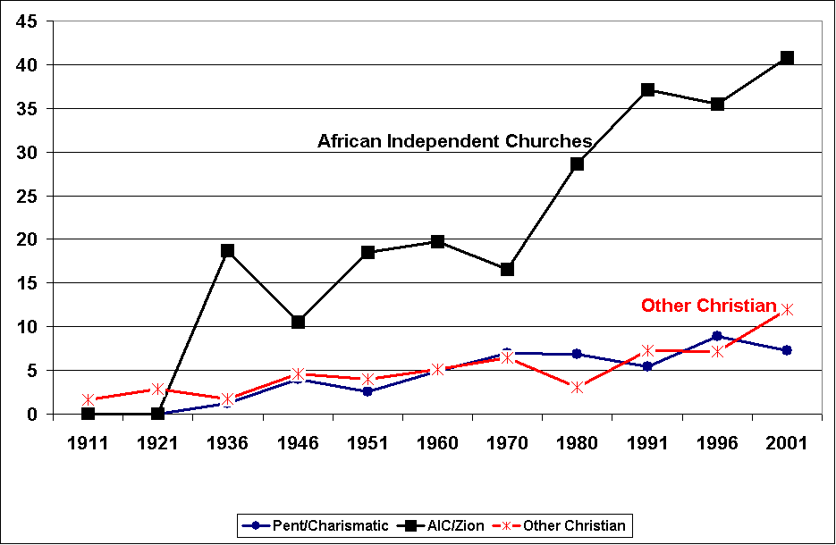

I discuss these statistics in some detail at the end of a paper and a chapter of a book that I published in 2008, however, here is a brief synopsis of that discussion.

Effectively these statistics clearly show that in Southern Africa the Church is in a decline while the Christian faith continues to grow. The growth segments are primarily to be found among African Initiated groupings and North American styled Pentecostal and Charismatic movements. I hesitate to call them Churches since many of them take on far more creative and non-conventional forms compared to what the average South African would consider a regular “Church” grouping. The Southern African context has some very clear social challenges, perhaps the two most significant challenges are poverty and HIV / AIDS. As a result the Christian groupings that have sought to find ways of addressing these issues have grown significantly. Here are the reasons that I suggest for their growth. [Slide 19]

- They are evangelical (even if their gospel is not entirely good news).
- They offer hope (particularly in addressing the most serious FELT needs of people):
  - Prosperity doctrine offers hope in poverty
  - Healing miracles and ministry offer hope in sickness
- The AIC’s are Contextually African
- They have a strong entrepreneurial leadership… (see the sigmoid curve) whereas we face significant pressure to maintain our ‘culture’ (e.g., uniforms, orders of service, hierarchies)
- They are ‘market oriented’ (changing in accordance with needs and pressures from outside), we are internally regulated (not responding to outside pressures and needs).

Coffey and Gibb suggest similar reasons for growth among Churches in North America:

Those churches experiencing growth, in defiance of the downward trends, are usually located in new suburban areas. They are acutely market sensitive and base their strategy on attracting the non-churchgoer into ‘seeker-sensitive’ worship services.

Moreover, they note that changes in immigration patterns play a significant role in western countries when it comes to the growth of faith communities. I’m sure that this can be borne out here in the United Kingdom? As far as my research shows the fastest growing, and largest Churches, are those made up of Africans, Latin Americans and other immigrant populations to the United Kingdom.

So, I do believe that the Christian faith is still finding a significant place in many societies across the world, even if some of those ‘places’ are neither ‘healthy’ nor ‘Christian’. But, what is also clear is that the faith is struggling to find, and maintain, that place within the established and mainline Churches. As I point out above, some of these expressions of faith are healthy and seek to bring the Gospel of Christ to bear upon the needs of communities with integrity and creativity. Other approaches are merely market driven and have dubious mechanisms of engaging persons and have even more alarming outcomes. As shall say one or two words about this in my concluding remarks.

So, to conclude this section, I think that Dave Walker from the ‘Church times blog’ summed up the matter succinctly with the following cartoon! [Slides 19-20]

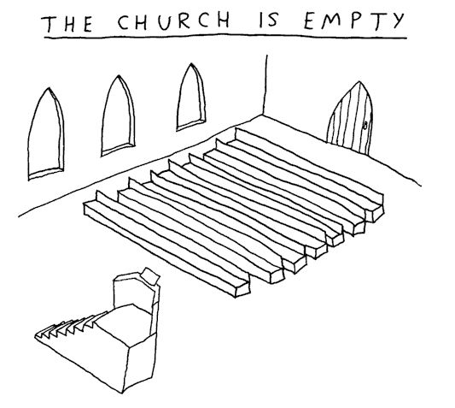
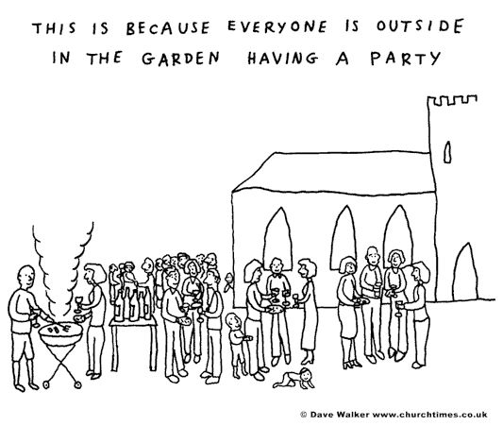

It is not so much that the content of the faith that no longer has a place in contemporary society, rather it is the means by which we engage persons with the faith, and those who long for faith outside of the Church, that is falling out of favour. I shall say more about this at a later stage since I do not think that we can simply throw out all of the rich heritage of doctrine, liturgy and community that is so central to the Church in order to adapt to changing contextual needs.

But perhaps these important characteristics of the Church are merely presented in the wrong order? Should they not possibly be facilitated as secondary steps in the faith process rather than our primary means of engagement with the world? For example, I find liturgy meaningful, but ‘un-Churhced’ friends find it both strange and unhelpful.

Let’s go on to consider some approaches and models that are either sensible, or are showing some positive results.

- Emergent, fresh and organic… Rediscovering the faith? Or, simply reinventing the Church?

[Slide 22] In recent decades there have been many encouraging and wonderful attempts at reinventing Christian community and mission across the world. I would venture that some of these have been attempts at rediscovering the very core of what it means to BE Christian – perhaps one could consider some of these attempts of revolutionary. Then there have also been many attempts at reinventing the Church so that the core of the Christian faith comes through strongly for those who believe. Perhaps this could be considered evolutionary. Regardless of which approach one takes (or a combination of both approaches), I am encouraged to say that there are so many of these that I cannot even begin to list the wonderful models and conversations I have encountered in South Africa, let alone those that I know of in the UK and elsewhere in the world where I have travelled with the Global Day of Prayer in the last few years! Thus, what I have chosen to do is give a brief overview of the three most common narratives that I encounter in my travels across the world. I shall not do this in a great deal of detail, since once again, there are far better researched and useful publications that do so. However, I do hope to give just a few brief insights into the theology of the emergent conversation.

Floyd McClung, gave the following very moving insight into the contemporary Church in a recent email he sent out to advertise his new book:

I believe that Jesus Christ started the New Testament Church… He started it as a community of men and women with a mission, a new purpose for their lives. He gathered them, invested in them, and then commissioned them to go and live what he had lived among them.
If we think of the Church as a celebration service that only happens in a building on Sundays, then Jesus doesn’t fit the model. We certainly won’t be able to call him ‘Pastor Jesus’…. If the Church is more dynamic than that; if indeed living like Jesus is how we should be and do Church, then thinking of Jesus and his band of followers as a Church community helps us have a more dynamic concept of what Church is all about.

As I have engaged with persons who have left the traditional Church in search of a more satisfying and engaging expression of the Christian faith community I have learned that most of them have not left the Church out of rebellion or anger, but rather out of a deep sense of personal conviction to Christ and a desire to find a more effective way of honouring Him and serving His will in society. Barna writes that the motive of these persons

… is borne out of a desire to return to our Lord with authenticity and fullness… the heart of the revolutionaries in not in question… They have a passion to be faithful to His Word and to be more in tune with His leading. They ardently want their relationship with the Lord to be their top priority in life. They are tired of the institutions, denominations, and routines getting in the way of a resonant connection with Him. They are worn out on the endless programs that fail to facilitate transformation… These are people who have experienced the initial realities of a genuine connection with God. They can no longer endure the spiritual teasing offered by churches and other well-intentioned ministries. God is waiting for them. They want Him. Mo more excuses.

The realisation that there is a need for new perspectives on Church and the faith community has given birth to a number of movements and conversations within contemporary Christendom. The most common collective noun applied to such groupings (and conversations) is the ‘emergent movement’ or the ‘emergent conversation’. [Slide 23]

The emerging church favors the use of simple story and narrative, occasionally incorporating mysticism and/or charism. Members of the movement often place a high value on good works or social activism, sometimes including missional living or new monasticism. While some Evangelicals may emphasize eternal salvation, many in the emerging church emphasize the here and now.

Some have noted a difference between the terms "emerging" and "Emergent." Whilst emerging is a wider, informal, church-based, global movement, Emergent refers to an official organization, the Emergent Village, associated with Brian McLaren, and has also been called the "Emergent stream."

Key themes of the emerging church are couched in the language of reform, Praxis-oriented lifestyles, Post-evangelical thought, and incorporation or acknowledgment of political and Postmodern elements. Many of the movement's participants use terminology that originates from postmodern literary theory, social network theory, narrative theology, and other related fields.

This rather lengthy definition of the emergent movement may not be very helpful without giving some thought to the values that underlie the conversation and movement. Richard Rohr, a Catholic theologian, gives four very helpful, and descriptive, categories that offer insight into the basic theological tenets that drive the emergent conversation (here I use the word conversation since he is advocating a renewal of how we are Church, rather than the formation of an entirely new form of Christianity community. I also deliberately chose to use the word ‘drive’ since this conversation is more a journey than a map. The conversation gives some pointers and road markers, but not the definitive destination). Here are Rohr’s four categories / aspects / characteristics of the emergent conversation:

- “an honest, broad, ecumenical Jesus scholarship”
- “a contemplative mind”
- “a conclusion that many of the major concerns of Jesus are at major variance with what most of our churches have emphasized”
- “new structures … new community mechanisms that can make this [new reformation] possible, because we don’t want to form a new denomination”.

In the section that follows I attempt to present a positive perspective on the theology that underpins the motivation and response for such expressions of Christian faith.

- Trinitarian values and the impact upon community and discipleship.

[Slide 24] There is the basic Christian acceptance of the doctrine of the Trinity as central to the Christian faith among most of the contributors to the emergent conversation. Yet, there are other ancillary elements of the notion of community that stem from this doctrine that are more central to the narrative of the emergent conversation. These include emulating the life of Jesus through contextual incarnation, sacrificial and justice oriented transformation of society (emulating the notion of perichoretic love that is central to the self-giving life of the persons of the Trinity), welcoming outsiders and bringing out unity in diversity (often expressed in charism rather than order). Ian Mobsby writes,

I suggest that perhaps the Emerging Church had found, or been led to a Trinitarian ecclesiology which had inspired a model, the values of which reflected God's desire for what the emerging church should be. This is what Volf is talking about in After our Likeness. A Church whose values reflect the Trinitarian God. This development appears not to have been a consciously mediated action, but to have emerged out of the experience and practice of those involved in the projects. Is this a God-led re-imagining of the Church? I believe that it is.

As a result of this emphasis on a Trinitarian character for community life, the values of equality and sharing are emphasised in emergent communities. Leadership is often shared with little or no distinction between persons working on a fulltime basis within the community structure and those who work outside of the community structure (unlike the distinction between ordained persons and the laity in contemporary mainline churches).

International research suggests that some Emerging Churches are utilizing a Trinitarian basis to being church through what Avery Dulles calls 'The Mystical Communion Model of Church'. [Slide 25]

- Not an institution but a fraternity.
- Church as interpersonal community.
- Church as a fellowship of persons - a fellowship of people with God and with one another in Christ.
- Connects strongly with the mystical 'body of Christ' as a communion of the spiritual life of faith, hope and charity.
- Resonates with Aquinas' notion of the Church as the principle of unity that dwells in Christ and in us, binding us together and in him.
- All the external means of grace, (sacraments, scripture, laws etc) are secondary and subordinate; their role is simply to dispose people for an interior union with God effected by grace.

Dulles comments on the strengths of this approach, and the fact that it should find acceptance among both protestant and Catholics in saying,

In stressing the continual mercy of God and the continual need of the Church for repentance, the model picks up Protestant theology... [and] in Roman Catholicism... when it speaks of the church as both holy and sinful, as needing repentance and reform...

The result of this approach is that participation in both the community and society is fluid and based upon needs and preference. There is a conscious effort to avoid relationships of power, thus rather than operating like a mechanism of interlinking cogs, the metaphor of organism better fits the emergent community. The structure and missional thrust of the community should be able to adapt easily to changes in the surrounding context and the requirements of the individuals and groups involved in the movement.

- Post-Christendom and how it shapes mission and evangelism.

Most contemporary Christians are not acutely aware of the subtle dichotomy between faith and life that has become commonplace in many western Christian communities. In its simplest form it is expressed in the kind of language we employ when talking about the Church, e.g., “Let’s go to Church”, or “The Church needs a new coat of paint”. Orthodox Christian ecclesiology is clear that the Church (ekklesia – c.f. Matt 16:18) literally refers to an ‘assembly, or group of people’. Moreover, the Biblical term denotes a people who are set aside for a particular task, not people who are set aside from the rest of society by location. The early Church met both in homes and in the marketplace and was a gathering that was structured around an obedient response to the will of Christ in ‘discipleship’, not ‘discipline’ (Acts 2:42-47). The word ‘Church’, as it is used in contemporary English, is an anglicised form of the Greek word kuriakē, meaning "of the Lord” (The Church is most likely a shortening of kuriakē oikia ‘house of the Lord’ which was first used in the writings of the Church Fathers towards the end of the second century AD). This understanding of Church denotes ‘a place’ (no longer ‘a people’). The emergent movement has sought to encounter this misshapen popular ecclesiology through placing a strong emphasis on ‘missional living’.

Participants in this movement assert that the incarnation of Christ informs their theology, believing that as God entered the world in human form, adherents enter (individually and communally) into the context around them, aiming to transform that culture through local involvement in it. This holistic involvement may take many forms, including social activism, hospitality, and acts of kindness.

This emphasis has often led to criticism from evangelical Christians since it shifts the emphasis of the gospel towards social and temporal issues rather than ‘eternal salvation’. Many emergent Christians, such as myself, consider themselves evangelical, but not in the narrow sense of the term as it has been used in contemporary North American Christianity. These emergent Christians are fundamentally committed to the transformation of individuals AND society by bringing the Gospel of Christ to bear on the sin that enslaves individuals, as well as the structural sins that enslave groups, nations and the world. As a result of the influences of post-modernism on the emergent conversation non-propositional approaches to evangelism are preferred. These include acts of mercy and justice, addressing the felt needs and social concerns of communities and individuals before attempting to proclaim the propositional truths of the Gospel. Among these groupings are the so-called ‘red letter Christians’, such as Jim Wallace and Tony Campolo. The name, red letter Christian, comes from the fact that they place a strong emphasis on living the direct teaching of Jesus (which was always printed in red letters in older printings of the Christian Bible). It is remarkable to see that when one studies the so-called ‘red letter’ sections of the New Testament they focus heavily on issues of social justice, structural and societal transformation, and the establishment of the Kingdom of God.

As such emergent faith groupings frequently encourage their members to enter into politics, the economic realm, and education – seeing such work as a vocation that can transform and renew society and the structures of society. I have recently encountered a number of business persons who believe themselves to be ‘ordained’ for societal transformation through using their business as a ministry to establish God’s Kingdom and transform society. Some go so far as to consider themselves ordained as ‘marketplace ministers’.

The end result of mission and evangelism for the emergent Christian is to restore all of existence (the whole of the cosmos, including human persons and the environment) to state of harmony with God. One can thus see that the missional emphasis is not upon building up the numerical adherence of the Christian faith, or bringing persons into Church communities, but rather to seek to infiltrate all spheres of society in order to establish the values and aims of God’s Kingdom throughout the whole of the structure of society.

- Creative and rediscovered spirituality.

Since the emphasis in the emergent conversation is on contextually relevant and authentic engagement with God in Christ, and bringing this engagement to bear upon one’s lived context, there are many varied approaches to Christian spirituality. These range from the use of technology (such as Rob Bell’s nooma video series), neocharismatic contemporary worship, to more ancient liturgical practises and customs (such a labyrinths, monastic communities, Taize, and even indigenous and cultural expressions of spirituality such as Celtic, African and even secular spiritualities).

Again, the influences of postmodernism can be evidenced when it comes to spirituality. Practitioners of emergent spirituality are normally quite comfortable to cross the former boundaries set up by institutional Churches, often borrowing elements from Catholic, Orthodox, Pentecostal, Evangelical, and even Eastern faith communities. Such movements have even been characterised as “Ancient future Churches” because of the desire to return to ‘ancient practises’ of the Church in the search for a deepened experience of God and the sacred in contemporary life.

The overarching emphasis, however, is to shift the emergent Christian from being a spiritual tourist (who is simply seeking spiritual experience) towards a reality of being a true spiritual pilgrim or deeply faithful disciple within his or her daily reality. The aim of such spiritualities is thus mission – bringing Christ and his Kingdom to bear on everyday life.

- The Kingdom of God and the Mission of the Church – evolution and revolution in the contemporary Church.

[Slide 28] Having considered these elements, I have a fairly simple, perhaps even simplistic, understanding of the kind of theology that could serve to encourage and drive the emerging conversation’s mission going forward.

God is, rightly, the centre and goal of all creation, all of history, and of course all human activity. Simply stated God is the source and reason for our life and being. Luke writes “In him we live and move and have our being” (Acts 17:28 NRSV). Anything that we do, either as individual Christians or as the Christian Church, should thus be focused upon the God in whom we live and move and have our being. As a result we cannot speak of the ‘mission of the Church’ apart from ‘God’s mission’. The Church has no mission of its own. Theologians refer to this mission as the missio Dei. This Latin term, which means the ‘sending of God’, was first coined by the German missiologist Karl Hartenstein in 1934 as a response to the term that Karl Barth frequently used, actio Dei (the ‘action of God’). Van Sanders writes,

When kept in the context of the Scriptures, missio Dei correctly emphasizes that God is the initiator of His mission to redeem through the Church a special people for Himself from all of the peoples (ta ethne) of the world. He sent His Son for this purpose and He sends the Church into the world with the message of the gospel for the same purpose.

The South African missiologist David Bosch has done more than any other theologian to develop this understanding of mission for the contemporary Church. He writes that, “the term mission presupposes a sender, a person or persons sent by the sender, those to who one is sent, and an assignment.” Of course such a perspective on mission is entirely in keeping with the concept of mission that we encounter in the New Testament. Remember the words of Jesus in John 20:21 (NRSV), “Jesus said to them again, ‘Peace be with you. As the Father has sent me, so I send you’.”?

So, the question that every Christian, and every Christian church / community, should be asking is “what is God’s mission for my life?” or, “what is God’s mission for our community?” This question is, however, not always that easily answered.

If we can understand what the ministry of the Church is, we should be able to understand what role each of us plays within that overall ministry. This question will no doubt raise many very valid and insightful answers. However, I am sure that we will all agree that the ministry of the Christian Church is to carry on doing the things that Jesus himself did! In other words, the Church must do the same ministry that Jesus does. So, that leads to the next question, “what is Jesus’ ministry?” The answer to this question can be found in such verses as Matthew 3:2, Mark 1:15, and most clearly in Jesus’ own words “I must preach the good news of the kingdom of God to other towns also, because that is why I was sent”(Luke 4:43). What does Jesus mean by this? Well, we can catch a glimpse of what Jesus understands this to mean by reading Luke 4:18-19:

The Spirit of the Lord is on me, because he has anointed me to preach good news to the poor. He has sent me to proclaim freedom for the prisoners and recovery of sight for the blind, to release the oppressed, to proclaim the year of the Lord's favour.

So, Jesus’ ministry is to establish God’s kingdom here on earth. God’s kingdom is a kingdom of justice, mercy, peace, wholeness, true and abundant life, and blessing. Here’s an example of what God’s kingdom should look like, as expressed in the Old Testament:

The wolf will live with the lamb, the leopard will lie down with the goat, the calf and the lion and the yearling together; and a little child will lead them. The cow will feed with the bear, their young will lie down together, and the lion will eat straw like the ox. The infant will play near the hole of the cobra, and the young child put his hand into the viper's nest. They will neither harm nor destroy on all my holy mountain, for the earth will be full of the knowledge of the LORD as the waters cover the sea. (Isaiah 11:6-9 NIV)

Here is another glimpse of what God’s kingdom should be like from a New Testament perspective:

And I heard a loud voice from the throne saying, "Now the dwelling of God is with men, and he will live with them. They will be his people, and God himself will be with them and be their God. He will wipe every tear from their eyes. There will be no more death or mourning or crying or pain, for the old order of things has passed away." He who was seated on the throne said, "I am making everything new! (Revelation 21:3-5a NIV).

So, the ministry of the Church is the same as the ministry of Jesus, that is, to establish God’s kingdom here on earth, in recent years we have understood that to mean that we are called to “proclaim the Gospel of Christ for healing and transformation”, and to work towards a “Christ healed Africa for the healing of the nations”. This means that everything that the Church does should not only proclaim God’s good news, but also make that good news real for people (as Jesus said, it must be good news to the poor, freedom to those who are enslaved, sight to those who cannot see, liberation for those who are oppressed and make known the year of God’s favour for all the earth).

So, your personal mission is to participate with other disciples in fulfilling the Church’s mission. The Church’s mission is to do the missio Dei i.e., to be ‘sent’ to do the ‘work’ and ‘mission’ of God. And, what is that mission? Well simply stated it is to let God’s will be done earth as it is in heaven – to establish the Kingdom of God!

Now, when we look at mission in this way, we can see that God is sending us to do more than just ‘make believers’, or ‘grow churches’. Rather, we are called to make disciples (people who not only receive Christ as Saviour, but also submit to him as Lord!)

You see, this is the work of responsible discipleship. Mission and discipleship are very closely linked in one of the missiological texts of the Bible:

Go therefore and make disciples of all nations, baptizing them in the name of the Father and of the Son and of the Holy Spirit, and teaching them to obey everything that I have commanded you. And remember, I am with you always, to the end of the age. (Matthew 28:19-20 NRSV)

Notice that when we read the ‘great commission’ the emphasis is upon making disciples, not merely believers. Discipleship is a costly affair. Unlike belief, which is quite easy, discipleship takes great personal sacrifice and courage. It is easy to believe in someone who dies to save you, someone who loves you so much that he will offer his life for yours – in fact anyone who does not accept such great love is not so clever…

However, to offer your life in return, out of love for the one who loves you sacrificially, is something quite extraordinary. In the contemporary Church there are many believers, but there are very few disciples. There are many of us who will call Jesus saviour, but very few who have the courage to submit to him as Lord.

True mission requires disciples – disciples are willing to pay the cost that is required to establish the Kingdom of God. The German theologian, Dietrich Bonhoeffer, who was killed by Hitler for his bold stance against national socialism (the political power behind the Nazi regime) wrote the following about mission and discipleship, “The call goes forth, and is at once followed by the response of obedience” and,

If we would follow Jesus we must take certain definite steps. The first step, which follows the call, cuts the disciple off from his previous existence. … The first step places the disciple in the situation where faith is possible. If he refuses to follow and stays behind, he does not learn how to believe.

Sadly, there are whole churches, even denominations, that have given up on discipleship. They have become so comfortable with Christ that they have forgotten what the call of the Gospel demands – as a result, it is my opinion that the world is moving away from the Church since it lacks a truly missional character.

- Conclusions and questions.

I hope that two simple, yet clear, things have come through this rather lengthy presentation.

First, that the Gospel of Christ is still necessary for contemporary society and that we need to find more effective means of bringing that Gospel to bear on society. Second, that the emergent conversation does not pose any substantial threat to orthodox ecclesiology and missiology. Rather, the conversation seeks to engender a fresh understanding and approach to what it means to be a Christian on community.

So, what is the answer to the question – do we require a revolution (a complete restart), or do we require a more subtle evolution? The answer is probably a bit of both! Would you expect any other answer from a theologian?! I suppose not, but it is the most honest answer I can give.

In relation to the notion of revolution I would venture that in some contexts we need some radically new models of being in community. The ‘old’ contemporary Church model simply does not do justice to the needs of society and the core of the Gospel of Christ. Together with that I do believe that we need to find some creative and fresh expressions of what it means to be in ‘full time’ Christian ministry. This will require that Christians have the courage to venture into fields and areas that may be somewhat misunderstood and less established (such as ‘marketplace ministries’, non-propositional forms of social evangelism etc.). I have little doubt that a revolution of Church structure is largely necessary since so much of the structure of the Church has become directed towards sustaining itself and is thus oppressive and counterproductive to the principles of the Kingdom of God and God’s mission in the world.

From an evolutionary perspective I am sure that you have seen many familiar themes and narratives from the history of Christian community and mission coming through clearly in the emerging conversation and Church movement. There is a healthy recognition of the need to value what we have from our history and Christian tradition. However, what is clear is that many of these elements need to be reenergized and refreshed in the light of changes in contemporary society.

I found the following suggestions from Coffey and Gibb extremely helpful in offering some insight into how we might do this. They suggest that we must change from:

- Living in the past to engaging with the present
- Market driven to mission-oriented
- Bureaucratic hierarchies to apostolic networks
- Schooling ‘professionals’ to mentoring servant leaders
- Following celebrities to encountering saints
- Dead orthodoxy to living faith (orthopraxy)
- Attracting the crowd to seeking the lost
- Belonging to believing
- Generic congregations to incarnational communities.

So, my prayer is that we will find both the courage and the critical insight to bring the Gospel of Christ to bear upon the world with courage and creativity – the whole Gospel has not lost its power to transform both individuals and society at large.

Delivered as a lecture on the 10th of March 2009 at Hinde Street Methodist Church, London, as part of the Hugh Price Hughes lecture series. For more about the author please see http://www.dionforster.com
Please refer to a detailed discussion of this notion in The appropriation of Wesleyan pragmatism and social holiness in Southern African Methodism. (Article published in Studia Historiae Ecclesiasticae in May 2008). This article was republished in an amended format in Forster, D & Bentley, W, God’s mission in our context – critical questions, healing and transforming responses. in ‘Methodism in Southern Africa. A celebration of Wesleyan Mission’. Kempton Park. AcadSA Publishers (2008:70-99).
In this paper I shall use the word Church in various forms. First, I shall use Church with a capital ‘C’ to refer to universal Church. Second I shall use the word church with a small ‘c’ to refer to denominations and local church groupings (what traditionally may have been called congregations). Third, I assume that there is a distinction (and not a separation) between the Church and the churches. The Church exists within, and outside of, the churches.
Craske in Methodism and the future: Facing the challenge. Craske, J & Marsh C. London. Cassel Publishers. (1999:161).
The research itself was done by an organisation called “Christian Research” http://www.christian-research.org.uk/. Times article on this research, which started the controversy over the statistics, can be found here, http://www.timesonline.co.uk/tol/comment/faith/article3890081.ece and here are some links to various insights and perspective on the research and the controversy that has surrounded it, http://www.ekklesia.co.uk/node/7112 and http://davidkeen.blogspot.com/2008/05/why-christian-research-is-wrong.html and http://www.churchtimes.co.uk/blog_post.asp?id=56454 with this being the official report from the Church of England http://www.cofe.anglican.org/news/pr4408.html. For very accessible and clear overview of Church attendance in the UK, with a number of helpful charts, please visit http://www.whychurch.org.uk/trends.php.
http://www.timesonline.co.uk/tol/comment/faith/article3890081.ece accessed 4 March 2009, 10.41.
http://www.timesonline.co.uk/tol/comment/faith/article3890080.ece accessed 4 March 2009, 10.41
http://www.ekklesia.co.uk/node/7112 accessed 3 March 2009, 19.43.
Gibbs, E & Coffey, I. Church next: Quantum changes in Christian ministry. Leicester: Intervarsity Press. (2001:17).
Gibbs, E & Coffey, I. Church next: Quantum changes in Christian ministry. Leicester: Intervarsity Press. (2001:17).
Wellings, M. A Historians perspective on the future of Methodism, in Methodism and the future: Facing the challenge. Craske, J & Marsh C. London. Cassel Publishers. (1999:148-157).
http://www.whychurch.org.uk/age.php accessed 4 March 19.30.
More red than green – a response to global warming and the environment from within the Methodist Church of Southern Africa. Forster, DA in The Epworth Review - the Journal of Methodist ecclesiology and mission Vol 35, No 2 (2008).
“Copenhagen Consensus Center - CCC Home Page,” http://www.copenhagenconsensus.com/Default.aspx?ID=788 (accessed December 22, 2007 10h56).
“The UN Millennium Development Goals,” http://www.un.org/millenniumgoals/ (accessed December 22, 2007 11h05).
Please see http://www.twitter.com/rogersaner (accessed 24 March 2009, 15.28) and http://jonnybaker.blogs.com/jonnybaker/2009/03/emerging-church-is.html (accessed 24 March 2009, 15.29).
Barna, G, & Viola, F. Pagan Christianity? Exploring the roots of our Church practices. New York. Tyndale Publishers. (2008: xxvii).
http://davidkeen.blogspot.com/2008/02/lightening-conductor.html accessed 3 March 2009, 18.23.
Peter Brierley in Gibbs, E & Coffey, I. Church next: Quantum changes in Christian ministry. Leicester: Intervarsity Press. (2001:20)
The appropriation of Wesleyan pragmatism and social holiness in Southern African Methodism. (Article published in Studia Historiae Ecclesiasticae in May 2008). This article was republished in an amended format in Forster, D & Bentley, W, God’s mission in our context – critical questions, healing and transforming responses. in ‘Methodism in Southern Africa. A celebration of Wesleyan Mission’. Kempton Park. AcadSA Publishers (2008:70-99).
Gibbs, E & Coffey, I. Church next: Quantum changes in Christian ministry. Leicester: Intervarsity Press. (2001:23).
Gibbs, E & Coffey, I. Church next: Quantum changes in Christian ministry. Leicester: Intervarsity Press. (2001:23).
http://www.churchtimes.co.uk/blog_post.asp?id=56419 accessed 3 March 19.50.
Floyd McClung in reference to his book You see bones, I see an army: Changing the way we do Church. 2008 Cape Town. Struik Christian publishers.
Barna, G, & Viola, F. Pagan Christianity? Exploring the roots of our Church practices. New York. Tyndale Publishers. (2008: xxv-xxvi).
http://en.wikipedia.org/wiki/Emergent_church accessed 4 March 2009, 19.22.
Please refer to http://www.spirituality.org.za/2009/03/four-helpful-and-sound-categories-for.html accessed 20 March 2009, 12.45, for the full post and a link to Rohr’s original video presentation from ‘Emergent Village’.
Please refer to http://www.spirituality.org.za/2009/03/four-helpful-and-sound-categories-for.html accessed 20 March 2009, 12.45.
Please see http://en.wikipedia.org/wiki/Perichoresis.
Mobsby, I. The Becoming of G-d, Oxford: YTCPress. (2008:67).
See Dulles, A. Models of Church, New York: Bantam Doubleday Dell Publishing Ltd. (1991).
See Dulles, A. Models of Church, New York: Bantam Doubleday Dell Publishing Ltd. (1991:46).
For a detailed discussion of this, and many other interesting related to the identity and functioning of the contemporary Church please refer to Barna, G, & Viola, F. Pagan Christianity? Exploring the roots of our Church practices. New York. Tyndale Publishers.
Griffiths, S. An Incarnational Missiology for the Emerging Church, in Rev Dr. Steve Griffiths speaks about the Emerging Church and how they view and approach missions. http://www.opensourcetheology.net/node/1116. Retrieved on 5 April 2009, 14.43.
A superb example of this approach is to be found in the Luke-10-Transformation approach to evangelism that is currently gaining a great deal of support in Southern African Churches and Christian groupings.
See Brian Mclaren’s book, Everything Must Change: Jesus, Global Crises, and a Revolution of Hope (Thomas Nelson, 2007).
I have written two books on this subject: Forster, DA. An uncommon spiritual path: The quest to find Jesus beyond conventional Christianity. Kempton Park. AcadSA Publishers. And, Forster, DA. Christ at the centre: Discoverning the Cosmic Christ in the spirituality of Bede Griffiths. Kempton Park. AcadSA Publishers.
Taylor, B. Entertainment Theology. Grand Rapids: Baker publishing house. (2008:96-102).
It is interesting to note that the word κινούμεθα (move), that Luke uses in Acts 17:28, is from the Greek root κινέω, which literally means to go from one place to another. However in the context of this passage, κινούμεθα means to “do what we do”. Hence, the activities of our lives find their origin, life, and meaning, in the God who is the source of all life.
V. Sanders, The Mission of God and the Local Church, in John M. Bailey (ed.) Pursuing the Mission of God in Church Planting, (Alpharetta,2006), 24.
David Jacobus Bosch, Transforming Mission: Paradigm Shifts in Theology of Mission (Orbis Books, 1991), 1
Here Jesus is quoting from the prophet Isaiah 61:1-2.
The Methodist Church of Southern Africa, 2007 yearbook and directory. (Methodist Publishing House, 2007), 2
See the passage from Luke 4:18-19 above.
Dietrich Bonhoeffer, The Cost of Discipleship (SCM Press, 2001), 61
Dietrich Bonhoeffer, The Cost of Discipleship (SCM Press, 2001), 66-67
Please see the chapter headings from Gibbs, E & Coffey, I. Church next: Quantum changes in Christian ministry. Leicester: Intervarsity Press. (2001:23).

