Hi Team,

Well, we’re just about through 1Q 2007 (that’s first quarter, for the 3 of you that don’t work for banks!). So far it feels like a race against the universe. I’m losing by 3 lengths and falling further behind!

So as I reflect briefly on what I’ve done with these precious months I have to ask myself if I’ve done anything meaningful. And I must admit, nothing immediately comes to mind. I mean, what is meaningful? Achieving balance? Finishing much-needed dance classes? Starting that poetry course? Getting my wine-tasting diploma… I mean “what is worthwhile for men to do under the sun”?

In my quest to benchmark the start of my year, I obviously turn to the only reliable source on post-modern meaning: Hollywood. And so I ask myself:
Have I come from a tragic upbringing, overcome myself, and risen to fame and fortunes untold and lived happily ever after? Mmm… Nope… that’s not it.

Have I taken Rome by stealth and might, wed her finest virgin and led her people with wisdom to my great glory til the end of my days? Mmm… not it either.
Have I come from behind as the underdog of underdogs and taken gold in the race of all races? Still not quite it…
Have I saved a life?… Have I saved a life?… Now I think we’re getting somewhere…

Have you? Have you ever looked into someone’s eyes and seen Death’s reflection staring back, and chased him away? Would that be worthwhile? I mean, what would that be worth? Read slowly now. What would that be worth to the ones they love? Think back to your favourite moment with your favourite person. Run it through in your mind. Just at the climax, when it can’t get sweeter, ask yourself: if Death intruded right now to inject her / him with terminal but slow cancer, what would you give to have Him stop? What would it be worth to you to stop their daily agony and restore the glimmer of life to their eyes? Would that be worthwhile?

Did you know in the time you read this question, 3 children will die from hunger?

In the time you read this email, more than 300 children will die from hunger. And I don’t mean in some impossible to reach backwater hell hole, where neither friend nor foe can reach. 150 people will die from hunger in South Africa, TODAY! In 2007, in this very year that we’re busy reflecting on, wondering “what is worthwhile for men to do under the sun?” 17million children will die from hunger. Most of them will look like this for months before they die:

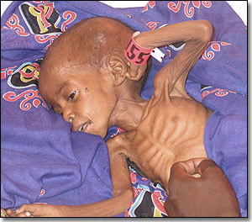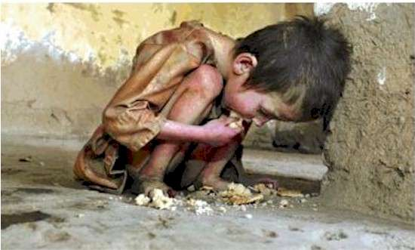

Most of them will eat grass before they die. But in the end, they will run out of grass. Then they will run out of energy to look for more grass. Then they will wait. And slowly, very slowly, death will overtake them.
Would it be worthwhile to save them? Would it be worthwhile to save even one, if you could only save one? Did you know that, if I enjoy having one glass of a R35 bottle of wine every night with dinner, if I from today instead pour that glass only half full each night and give the savings to hunger organisations, I will be helping one less child look like that and die like that? Or if I regularly go out for pricey night out, if from now on I rather stay home just once every 2 months and give the savings to hunger organisations, I will be helping one less child look like that and die like that. Did you know it costs R120 per month to feed one of these children? Did you know that if we spent 0.2% of the global arms budget on hunger, not a single child would die of hunger? 17,000,000 lives would be saved EVERY YEAR. Did you know that if we spent 20% of the global plastic surgery spend, not a single child would die of hunger? 17,000,000 lives would be saved EVERY YEAR.
Aids can not yet be cured. Hunger can. There are oodles of organisations out there nursing kids like this back to health and life. Not enough, for sure. Not nearly enough. But they’re out there. For example, WorldVision accepts a debit order, and 87% of their donations reach the final beneficiaries (i.e. not wasted on overheads). 5 minutes to set up a R120 monthly debit order will save a life.
So no, I have not done anything significant with my first quarter. But there are 2 weeks left. I plan to. www.worldvision.org
Take care. "Remember the poor.” God bless
Jason

